Going Viral

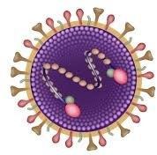
Respiratory Syncytial

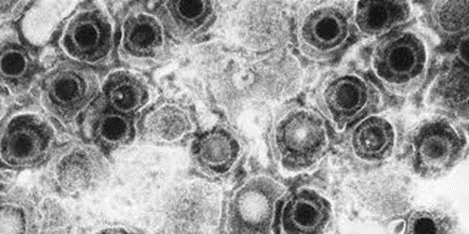
Herpes Simplex

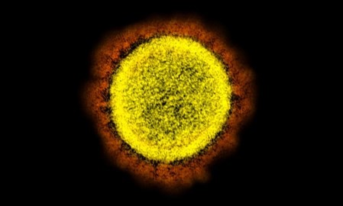
Coronavirus

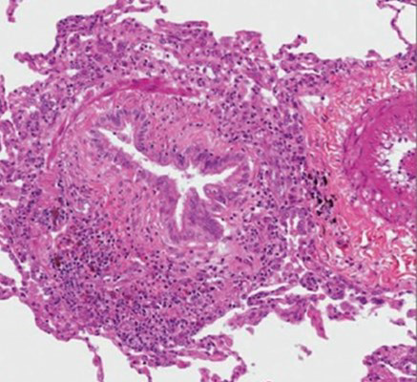
Bronchiolitis

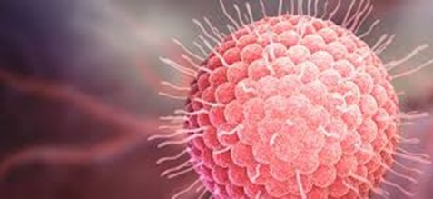

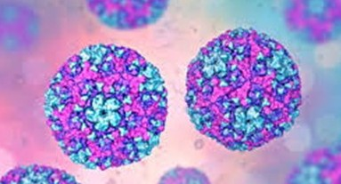
Enterovirus
Zika Virus

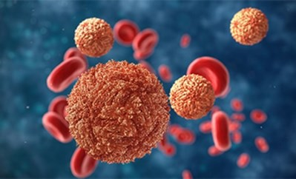

Cytomegalovirus

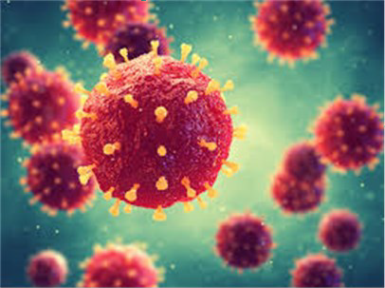

August 28, 2020
Bradley Lecture Center Birmingham, AL

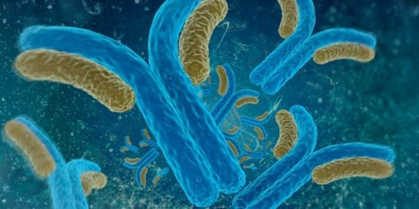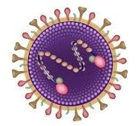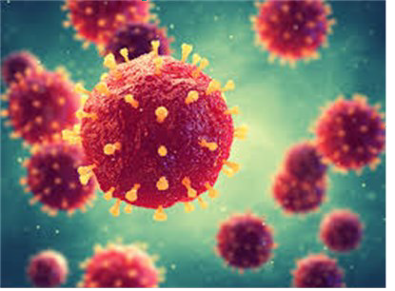

OBJECTIVES
Upon completion of this live activity, participants will be able to:

- Discuss the infectious agents, how to recognize, diagnose and treat these viruses.

IgG Antibodies

AGENDA

7:30a – 8:00a | Registration and Continental Breakfas
8:00a – 8:05a | Welcome -  Joseph Philips, M.D. Samuel Gentle, M.D.  Tara McNair, R.N., B.S.N.
8:05a – 8:30a | Virology 101  Joseph Philips, M.D.
8:30a – 9:15a | Cytomegalovirus Bill Britt, M.D.
9:15a – 10:00a | Herpes Simplex David Kimberlin, M.D.
10:00a - 10:15a | Break
10:15a – 11:00a | Respiratory Syncytial Virus  Samuel Gentle, M.D.
11:00a – 11:45a | Enterovirus Claudette Poole, MD
11:45a – 1:00p | Lunch (provided)
1:00p – 1:45p | Zika Virus  Sergio Stagno, MD
1:45p – 2:30p | Varicella  Cecelia Hutto, MD
2:30p – 2:45p | Break
2:45p – 3:30p | Bronchiolitis  Samuel Gentle, MD
3:30p – 4:15p | Coronavirus Nazia Kabani, MD
4:15p – 5:00p | Plagues and Pandemics Joseph B. Philips, MD

SPEAKERS

Samuel Gentle, M.D. Assistant Professor Division of Neonatology

Joseph B. Philips, III, M.D.
Professor
Director, PPHN Program Division of Neonatology

William “Bill” Britt, MD
Charles A. Alford Professor of Pediatrics Professor of Microbiology & Neurology Department of Pediatrics Infectious Disease

David Kimberlin, MD
Co-Division Director, Division of Pediatric Infections Disease
Sergio Stagno, MD., Endowed Chair in Infectious Disease
Vice-Chair for Clinical and Translational Research, UAB Pediatrics
Professor

Sergio Stagno, MD
Distinguished Professor
Chair Emeritus, UAB Department of Pediatrics Past President, UA Health Service Foundation, P.D.
Division of Pediatrics Infectious Disease

Claudette Poole, MD
Assistant Professor
Associate Program Director, Pediatric Infectious Diseases Fellowship Program
Division of Pediatrics Infectious Disease

Cecelia Hutto, MD
Medical Director, Hospital Infection Control
Division of Pediatric Infectious Disease

Nazia Kabani, MD
Fellow
Department of Pediatrics, Divisions of
***Please note that in order to receive CME credit, you MUST fill out an evaluation after viewing Perinatal Conference either on our website or use the link below.
Evaluation Link: Sent via email

ACCREDITATION
Children’s of Alabama designates this live activity for a maximum of 7.25 AMA PRA Category 1 Credits™.
Physicians should claim only the credits commensurate with the extent of their participation in the activity.

Children’s of Alabama is accredited by the Medical Association of the State of Alabama to provide continuing medical education for physicians.

No application to the Alabama Board of Nursing has been made. Per Alabama Administration Code Chapter 610-X-10-.04e, AMA PRA
Category 1 Credits™ are acceptable for CEUs. CME conversion to CEUs for this conference equals 9.3 Continuing Education Hours. To receive the Nursing Contact Hours, go to the Alabama Board of Nursing website: www.abn.alabama.gov
- Click on Continuing Education (on the gray bar in purple letters)
- Click on Access Individual CE Record
- When the Individual CE Record page opens, follow the directions on the screen.
All participants will receive a Certificate of Attendance showing the total number of Contact Hours received.

COORDINATORS
Joseph B. Philips, III, MD Samuel Gentle, MD
Tara McNair, RN, BSN Julie Sai’d
Tammie Vines

Department of Pediatrics Division of Neonatology Women and Infants Center 176F Suite 9380
619 South 19th Street Birmingham, AL 35249-7335

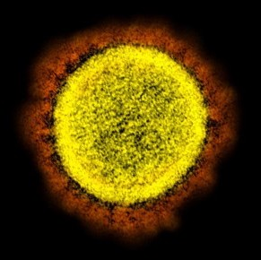

Coronavirus

Registration Form
August 28, 2020
PLEASE REGISTER IN ADVANCE BY COMPLETING THIS ENROLLMENT FORM.
MAIL REGISTRATION FORM AND FEE TO ADDRESS BELOW OR FAX IT TO (205) 934-3100.
REGISTER EARLY, SEATING IS LIMITED

Please type or print clearly

Name: Degree (MD, RN, RT, etc.) Hospital/Practice Email address: Mailing Address City State/Zip Office # Home/Cell #: Fax # (Confirmation will be sent via e-mail or Fax ONLY)

Course fee:
- $ 35.00 (Virtual Conference)
For more information contact: Julie Sai’d - jsaid@peds.uab.edu or Tammie Vines - tvines@peds.uab.edu at
Make check payable to UAB Neonatology and mail
to:

ATTN: Perinatal Conference UAB Division of Neonatology 176F Suite 9380
619 South 19th Street

